**TRANSMITTER SIDE**

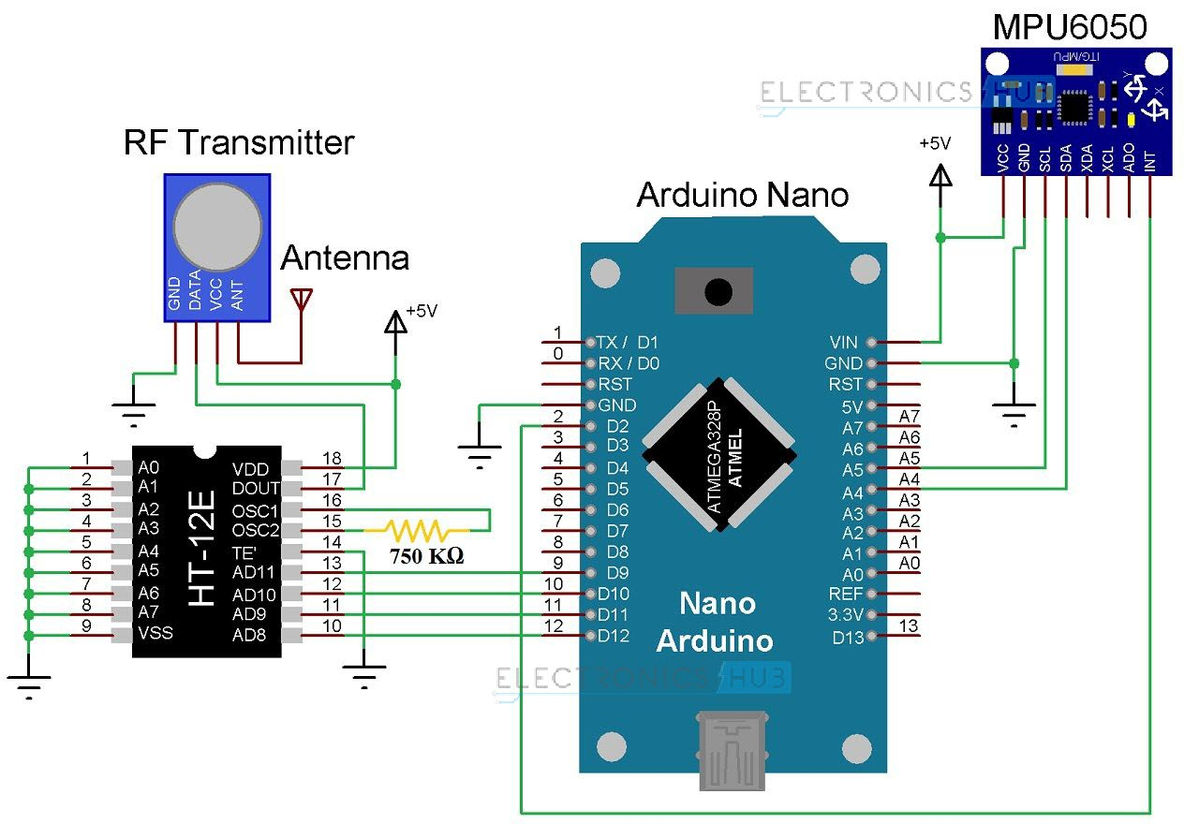

**Components for Transmitter Section**

* Arduino Nano
* 434MHz RF Transmitter
* HT-12E Encoder IC
* MPU6050 Accelerometer/Gyroscope Sensor
* 750KΩ Resistor

#### Transmitter Section

The transmitter section of the robot consists of Arduino Nano board, MPU6050 Sensor, HT-12E Encoder IC and an RF Transmitter. The communication between Arduino and MPU6050 Sensor takes place through I2C Interface. Hence, the SCL and SDA pins of the MPU6050 Sensor are connected to A5 and A4 pins of the Arduino Nano.

Additionally, we will be using the interrupt pin of the MPU6050 and hence, it is connected to D2 of Arduino Nano.

HT-12E is an encoder IC that is often associated with RF Transmitter module. It converts the 12-bit parallel data to serial data. The 12-bit data is divided into address and data bits. A0 to A7 (Pin 1 to Pin8) are the address bits and they are used for secure transmission of the data. These pins can be either left open or connected to ground (Vss). In this circuit, Pin 1 to Pin 9 (A0 – A7 and Vss) of HT-12E are connected to ground.

Pins 10 to 13 (AD8, AD9, AD10 and AD11) are the data pins of HT-12E. They receive the 4 word parallel data from external source like a microcontroller (Arduino Nano in this case). They are connected to the pins D12, D11, D10 and D9 of Arduino Nano respectively.

TE’ is the transmission enable pin and it is an active low pin. The data is transmitted as long as the TE’ is low. Hence, Pin 14 (TE’) is also connected to ground.

The encoder IC has an internal oscillator circuit between the pins 16 and 15 (OSC1 and OSC2). A 750KΩ resistor is connected between these pins to enable the oscillator. Dout (Pin 17) is the serial data out pin. It is connected to the data in pin of the RF Transmitter.

Both Arduino Nano and MPU6050 have 3.3V Regulator. Hence, all the VCC pins are connected to a regulated 5V Supply.